COMMON COURSE ASSIGNMENT
CSA0402 – OPERATING SYSTEMS | Covering CO2, CO3 & CO4
NAME:R JESINTHA BAKIYA RATHI[192511410]

A. Assignment Information
Department | Computer Science and Engineering
Programme | B.E. / B.Tech – CSE
Course Code & Course Name | CSA04 – Operating Systems
Academic Year / Batch | 2026 – 2027
Faculty Name | Dr J Priskilla Angel Rani
Assignment Title | Design and Analysis of an OS Resource Orchestration System for a Smart University
Date of Issue | 25-08-26
Date of Submission | 28-08-26
Maximum Marks | 100
Course Outcome(s) – CO | CO2, CO3, CO4
Bloom's Taxonomy Level | L3 – Apply, L4 – Analyse, L5 – Evaluate
SDG Mapping | SDG 7 – Affordable and Clean Energy; SDG 9 – Industry, Innovation and Infrastructure; SDG 11 – Sustainable Cities and Communities
Industry / Societal Relevance | Efficient OS resource management is fundamental to cloud platforms, university servers, digital public services and energy-aware computing.

B. Assignment Problem / Challenge
Students are required to design and analyze an Operating System Resource Orchestration System for a smart university. The system must manage a changing workload generated by online examinations, digital classrooms, library services, research jobs, backup services and campus IoT monitoring. The assignment integrates process management, synchronization and deadlock handling, memory management, file allocation and disk scheduling. Students must construct their own workload, apply suitable OS algorithms, validate the results using calculations and/or programs, compare alternatives, and make evidence-based engineering decisions.

C. Problem Statement

Scenario: OS Resource Orchestration for “UniCore” – A Smart University Computing Platform
UniCore is a university computing platform supporting 500 concurrent users during normal operation and more than 800 users during online examination periods. It provides learning-management services, examination processing, digital-library access, research computing, automated backups and IoT monitoring. Multiple processes compete for CPU time, memory frames, files and I/O devices. Some services are interactive and response-sensitive, while others are long-running background jobs.
As the OS design team, students must propose and evaluate solutions in three major areas:
- Process Management, Synchronization & Deadlock (CO2): concurrent processes access shared examination records, logs and limited resources. The design must avoid race conditions and handle unsafe resource requests.
- Memory Management (CO3): physical memory is limited while many services execute concurrently. The design must use paging/virtual memory concepts and control page faults and thrashing.
- File Systems & Disk Scheduling (CO4): the platform stores files ranging from small student records to large lecture recordings and generates simultaneous disk requests. The design must balance access speed, fairness and storage efficiency.

D. Requirements and Constraints
- Functional: support concurrent user services and shared-file access without race-condition-induced corruption.
- Workload: construct at least 8 processes and at least 4 resource types for analysis.
- Memory: assume 16 GB physical RAM and a 4 KB page size unless a different value is justified.
- Storage: assume a 200-cylinder disk and at least 10 pending requests for disk-scheduling analysis.
- Reliability: the design must identify unsafe/deadlock states and provide avoidance, detection or recovery logic.
- Performance: minimize average waiting time, page faults and disk-head movement while considering fairness.
- Resource limitation: assume a finite number of database/file-lock/print resources and clearly state the allocation.
- Technical: use open-source tools such as C/C++, Python, Linux/WSL or an OS simulator.
- Security/Privacy: shared academic files must preserve access control and data integrity.
- Standards: follow standard Operating Systems principles and POSIX/Linux conventions where applicable.

E. Student Work

1. Problem Understanding and Formulation
- Restate the UniCore problem in your own words.
- Identify CPU, synchronization, memory, file-system and disk-I/O challenges.
- Define the workload and all assumptions, including process parameters, resources, page/frame size and disk request queue.
- Identify measurable objectives such as waiting time, response time, page faults, safe-state status and disk head movement.
- Explain the constraints that your final design must satisfy.

2. Application of Course Knowledge (CO2, CO3, CO4)
Answer the following parts with complete working, algorithms/pseudocode, calculations and justification.

Part I – Process Management, Synchronization & Deadlock (CO2)
- Model a shared examination-record access problem using Readers–Writers, Producer–Consumer or another appropriate classical synchronization problem. Write semaphore/monitor pseudocode and explain how race conditions are prevented.
- Construct Allocation, Maximum and Available matrices for at least 4 processes and 4 resource types. Apply the Banker's Safety Algorithm, show the Need matrix, work updates and safe sequence.
- Create one additional resource request that makes the system unsafe. Demonstrate how the request should be handled.
- Compare deadlock prevention, avoidance, detection and recovery for UniCore and justify the selected strategy.
- Analyse how the selected CPU scheduling policy would affect interactive examination services versus background backup jobs. Use at least two scheduling algorithms.

Part II – Memory Management (CO3)
- For 16 GB physical memory and 4 KB pages, calculate the number of available frames. For a 64 MB logical address space, calculate the number of pages and explain the page-table organization.
- Construct a reference string of at least 15 page references. Using 3 and 4 frames, compare FIFO, LRU and Optimal page replacement. Show page-by-page working and total page faults.
- Analyse whether increasing frames always reduces page faults for your selected reference string. Discuss Belady’s anomaly where applicable.
- Explain demand paging, working sets and thrashing for the 800-user examination workload. Propose a frame-allocation/working-set policy.
- Discuss how linking/dynamic linking or storage requirements can influence memory utilization in the proposed environment.

Part III – File Systems & Disk Scheduling (CO4)
- Compare contiguous, linked and indexed allocation for small student records, medium documents and large lecture videos. Recommend an allocation strategy for each category.
- For a 200-cylinder disk, construct at least 10 requests and state the initial head position. Calculate total head movement for FCFS, SSTF and SCAN or C-SCAN.
- Compare the selected disk algorithms using seek performance and fairness. Explain whether the best average seek result is necessarily the best production choice.
- Relate your recommendation to Unix file-system concepts such as inodes and buffer cache.
- Explain how file allocation and disk scheduling together influence application response time.

3. Solution / Design / Methodology
Integrate Parts I–III into one UniCore OS resource-management design. Present:
- A process/synchronization design with deadlock-handling strategy.
- A memory-management design with paging, page replacement and thrashing-control policy.
- A file-system and disk-scheduling design.
- An architecture/flow diagram showing how a user request moves through process management, memory management, file system and disk I/O.
- A decision matrix comparing alternative algorithms against performance, fairness, reliability and implementation complexity.

4. Use of Modern Tools
- Python/C/C++: simulate Banker’s Algorithm, CPU scheduling, page replacement and disk scheduling.
- Linux/WSL: demonstrate process/file operations and one IPC or POSIX-thread synchronization example.
- OS simulator/visualizer: optionally cross-check manual calculations.
- GitHub: maintain source code, test cases, results and documentation with meaningful commits.

5. Results and Validation
- CPU scheduling: Gantt chart and waiting/turnaround/response-time comparison.
- Synchronization/deadlock: safety trace, safe sequence and unsafe-request result.
- Memory: FIFO/LRU/Optimal page-fault comparison for two frame counts.
- Disk: total head movement and comparative performance.
- Validation: include at least one normal case and one adverse case such as unsafe state, starvation, thrashing or heavy disk load.

6. Analysis and Engineering Decision
- Identify the most suitable scheduling strategy for UniCore and justify it using calculated metrics.
- Compare page-replacement algorithms and recommend one for the workload.
- Compare disk algorithms considering both seek efficiency and fairness.
- Justify the deadlock strategy against alternative approaches.
- Use the quantitative results to defend the integrated design.

7. Broader Considerations
- Reliability & Safety – explain how shared academic data is protected from inconsistent concurrent updates.
- Sustainability – explain how efficient CPU, memory and disk usage can reduce energy consumption and hardware pressure.
- Accessibility & Society – discuss fair service for users during peak examination load.
- Ethics & Professional Responsibility – address student-data privacy, access permissions and responsible use of system resources.

8. Conclusion
Summarize the integrated OS design, major quantitative findings, final algorithm choices, satisfied constraints, limitations and possible future improvements.

9. Student Reflection
- What did you learn by integrating process, memory and file-system concepts instead of treating them independently?
- Which design decision had the greatest impact on system performance and why?
- What would you improve if the workload were increased from 800 to 2,000 concurrent users?

10. References
Cite textbooks, Linux/POSIX documentation, datasets, simulators and AI-assisted tools used. Recommended core references include Silberschatz, Galvin & Gagne, Operating System Concepts; Maurice Bach, The Design of the UNIX Operating System; William Stallings, Operating Systems – Internals and Design Principles; and Andrew S. Tanenbaum, Modern Operating Systems, F. Common Assessment Rubric

Assessment Criterion | Marks | Excellent | Good | Satisfactory | Needs Improvement
Problem understanding & formulation | 10 | Complete and realistic formulation; assumptions and constraints clearly justified. | Most requirements identified; minor gaps. | Basic formulation with limited justification. | Requirements poorly understood or assumptions unsupported.
Application of course knowledge (CO2, CO3, CO4) | 20 | Correct application of process, deadlock, memory and file/disk concepts with complete working. | Mostly correct with minor errors. | Basic application with incomplete analysis. | Major conceptual or calculation errors.
Solution methodology / design / implementation | 20 | Integrated, modular design with correct pseudocode/implementation and clear architecture. | Good design with minor implementation gaps. | Basic design; limited integration. | Major modules missing or non-functional.
Use of appropriate modern tools / techniques | 10 | Tools are used meaningfully to implement, simulate and cross-check results. | Appropriate tools used with minor gaps. | Basic tool usage shown. | Tool usage absent or inappropriate.
Results, testing & validation | 15 | Comprehensive test cases, accurate results and strong validation of normal/adverse cases. | Good validation with minor gaps. | Limited test coverage or evidence. | Results unreliable or not validated.
Analysis, trade-offs & justification | 15 | Strong quantitative comparison and evidence-based final decisions. | Good comparison and justification. | Some comparison but weak justification. | Little or no meaningful analysis.
Broader considerations / professional responsibility | 5 | Clear treatment of reliability, sustainability, accessibility, privacy and ethics. | Most areas addressed. | Basic discussion. | Missing or superficial.
Technical documentation & reflection | 5 | Excellent documentation, reflection and reproducibility. | Good documentation/reflection. | Basic documentation. | Poor documentation or reflection.

G. CO–PO–Assessment Mapping
Assessment Component | CO | PO(s) | Bloom's Level / Marks
Problem formulation | CO2 | PO1, PO2 | L3 – 10
Process synchronization, scheduling & deadlock | CO2 | PO1, PO2, PO3 | L3/L4 – 20
Memory-management design | CO3 | PO2, PO3 | L4/L5 – 10
File allocation & disk scheduling | CO4 | PO2, PO3 | L4/L5 – 10
Modern tool usage | CO2, CO3, CO4 | PO5 | L3 – 10
Results, testing & validation | CO2, CO3, CO4 | PO4 | L4/L5 – 15
Analysis, trade-offs & engineering decision | CO2, CO3, CO4 | PO2, PO4 | L4/L5 – 15
Broader considerations, documentation & reflection | CO2, CO3, CO4 | PO6, PO12 | L3/L4 – 10
Note: PO numbers are illustrative and should be verified against the current institutional CSA04 CO–PO matrix before final use.

H. Faculty Evaluation & Continuous Improvement
CO Attainment | ________________________________________
Performance Level | Level 3 ≥ 70% | Level 2: 60–69% | Level 1: 50–59% | Level 0 < 50%
Target CO Attainment | ________________________________________
Actual CO Attainment | ________________________________________
Areas in which students performed well | ________________________________________  ________________________________________
Areas requiring improvement | ________________________________________  ________________________________________
Corrective / Improvement Action | ________________________________________  ________________________________________
Action for next offering | ________________________________________  ________________________________________

Deliverables

1. Problem formulation and assumptions
2. Pseudocode / flowcharts
3. Implementation / source code
4. Test cases and results
5. Architecture/design diagrams
6. Comparative analysis tables/graphs
7. Final engineering decision and justification
8. GitHub repository link containing README, source code, test cases, results and report
9. Final report and student reflection

H. Faculty Evaluation & Continuous Improvement
CO Attainment Performance Level
Criterion
Level 3 | >= 70%
Level 2 | 60-70%
Level 1 | 50-59%
Level 0 | <50%

Target CO Attainment: ______________ Actual CO Attainment: ______________
Faculty Analysis
Areas in which students performed well: ____________________________________________________
Areas requiring improvement: ____________________________________________________
Corrective / Improvement Action: ____________________________________________________
Action to be implemented in the next offering: _____________________________

1. Problem Understanding and Formulation
1.1 Problem Understanding
UniCore is a smart university computing platform designed to support approximately 500 concurrent users during normal operation and more than 800 concurrent users during online examination periods. The platform provides several important services, including Learning Management System (LMS) services, online examination processing, digital library access, research computing, automated backup services and campus IoT monitoring.During peak periods, a large number of processes execute simultaneously and compete for limited system resources such as CPU time, memory frames, files, database locks and I/O devices. Interactive services such as online examinations and digital classrooms require quick response times, while background activities such as backups and research computations can tolerate longer execution times.
Therefore, an efficient Operating System resource orchestration system is required to manage processes, synchronize shared resources, prevent or avoid deadlocks, allocate memory efficiently, manage files and schedule disk requests. The proposed design applies Operating System concepts from process management, synchronization, deadlock handling, memory management, file allocation and disk scheduling to create a reliable and efficient UniCore environment. This directly addresses the assignment requirement to integrate these OS components into a single resource-management design.
1.2 Problem Formulation
The major problem is to design an OS resource-management system that can efficiently handle changing workloads generated by online examinations, digital classrooms, library services, research jobs, backup services and IoT monitoring.
The system must:
- Manage multiple concurrent processes efficiently.
- Provide fair CPU allocation between interactive and background processes.
- Prevent race conditions when multiple processes access shared examination records and logs.
- Detect and avoid unsafe resource-allocation states.
- Efficiently allocate physical memory using paging and virtual memory concepts.
- Minimize page faults and prevent excessive thrashing.
- Provide suitable file-allocation methods for different types of university data.
- Minimize disk-head movement while maintaining fairness.
- Protect academic data through proper access control and synchronization.
- Maintain acceptable response time during peak examination workloads.
The assignment specifies a workload of at least 8 processes and at least 4 resource types, 16 GB physical RAM with a 4 KB page size, and a 200-cylinder disk with at least 10 pending requests.
1.3 Major OS Challenges
CPU and Process Management:
The system must schedule interactive examination processes and background jobs efficiently while minimizing waiting time, turnaround time and response time.
Synchronization:
Multiple processes may simultaneously access shared examination records, logs and files. Synchronization mechanisms such as semaphores or monitors are required to prevent race conditions and inconsistent data.
Deadlock Management:
Processes may compete for multiple limited resources. The system must identify unsafe states and use an appropriate deadlock avoidance, prevention, detection or recovery strategy.
Memory Management:
Since many services execute concurrently, physical memory must be managed efficiently. Paging, page replacement and working-set techniques are required to control page faults and prevent thrashing.
File and Disk Management:
UniCore stores different types of data, from small student records to large lecture videos. Suitable file-allocation and disk-scheduling strategies are required to achieve good performance and fairness.
1.4 Workload and Assumptions
Parameter | Assumption
Normal concurrent users | 500
Peak concurrent users | 800+
Number of processes | 8
Resource types | 4
Physical RAM | 16 GB
Page size | 4 KB
Logical address space | 64 MB
Disk size | 200 cylinders
Disk requests | 10+
Operating environment | Linux/POSIX concepts
Simulation language | Python
The workload will include processes representing online examination services, digital classrooms, library services, research computing, backup operations and IoT monitoring.
1.5 Measurable Objectives
The performance of the proposed system will be evaluated using:
- Average CPU waiting time.
- Average turnaround time.
- Response time for interactive services.
- Safe-state status using Banker’s Algorithm.
- Total number of page faults.
- Comparison of page faults for 3 and 4 frames.
- Total disk-head movement.
- Fairness between competing processes.
- Occurrence of adverse conditions such as unsafe states, thrashing or heavy disk load.
- Overall reliability and resource utilization.
These measurements will be used to compare alternative algorithms and make the final engineering decisions.
1.6 Constraints
The proposed UniCore system must operate within finite CPU, memory, storage and I/O resources. It must support concurrent services without corruption of shared academic data. The design must also consider performance, reliability, fairness, security and privacy.
The system should minimize waiting time, page faults and disk-head movement without sacrificing fairness. Academic files must be protected through appropriate access permissions and synchronization mechanisms. The implementation will use open-source tools such as Python and Linux/WSL where appropriate.

2. Application of Course Knowledge (CO2, CO3, CO4)
Part I – Process Management, Synchronization & Deadlock (CO2)
2.1 Readers–Writers Problem
CODE REQUIRED — Run this in Python and take a screenshot of the code and output.
import threading
import time
import random
# Shared examination record
exam_record = {
"student_marks": 85
}
# Reader count and locks
read_count = 0
read_count_lock = threading.Lock()
resource_lock = threading.Lock()
def reader(reader_id):
global read_count
# First reader locks the shared resource
with read_count_lock:
read_count += 1
if read_count == 1:
resource_lock.acquire()
print(f"Reader {reader_id} is reading marks: {exam_record['student_marks']}")
time.sleep(random.uniform(0.5, 1))
# Last reader releases the shared resource
with read_count_lock:
read_count -= 1
if read_count == 0:
resource_lock.release()
print(f"Reader {reader_id} finished reading.")
def writer(writer_id, new_marks):
# Writer gets exclusive access
with resource_lock:
print(f"Writer {writer_id} is updating marks...")
time.sleep(1)
exam_record["student_marks"] = new_marks
print(f"Writer {writer_id} updated marks to {new_marks}.")
# Create reader and writer threads
threads = []
threads.append(threading.Thread(target=reader, args=(1,)))
threads.append(threading.Thread(target=reader, args=(2,)))
threads.append(threading.Thread(target=writer, args=(1, 90)))
threads.append(threading.Thread(target=reader, args=(3,)))
# Start all threads
for thread in threads:
thread.start()
# Wait for all threads to finish
for thread in threads:
thread.join()
print("\nFinal Examination Record:")
print("Student Marks:", exam_record["student_marks"])

OUTPUT:

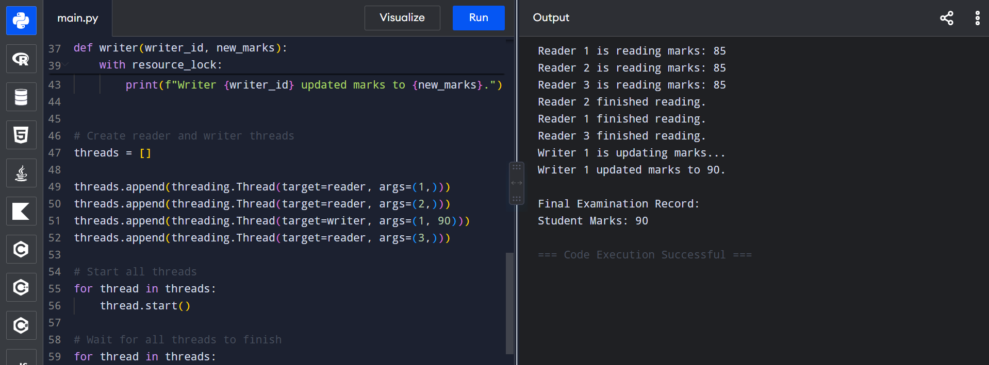

2.2 Banker's Safety Algorithm
CODE REQUIRED — Run this Python code and take screenshots of the code + output.
# Banker's Safety Algorithm for UniCore

processes = ["P0", "P1", "P2", "P3"]
# Allocation Matrix
allocation = [
[0, 1, 0, 0],
[2, 0, 0, 1],
[3, 0, 2, 0],
[2, 1, 1, 0]
]
# Maximum Matrix
maximum = [
[7, 5, 3, 2],
[3, 2, 2, 2],
[9, 0, 2, 2],
[2, 2, 2, 2]
]
# Available Resources
available = [3, 3, 2, 2]
# Calculate Need Matrix
need = []
for i in range(len(processes)):
row = []
for j in range(len(available)):
row.append(maximum[i][j] - allocation[i][j])
need.append(row)

print("NEED MATRIX")
for i in range(len(processes)):
print(processes[i], need[i])
# Banker's Safety Algorithm
work = available.copy()
finish = [False] * len(processes)
safe_sequence = []
print("\nSAFETY CHECK")
while len(safe_sequence) < len(processes):
found = False
for i in range(len(processes)):
if not finish[i]:
if all(need[i][j] <= work[j] for j in range(len(work))):
print(f"{processes[i]} can execute")
for j in range(len(work)):
work[j] += allocation[i][j]
print("Work after", processes[i], "=", work)
finish[i] = True
safe_sequence.append(processes[i])
found = True
if not found:
break
print("\nRESULT")
if len(safe_sequence) == len(processes):
print("System is in SAFE STATE")
print("Safe Sequence:", " -> ".join(safe_sequence))
else:
print("System is in UNSAFE STATE")

OUTPUT:
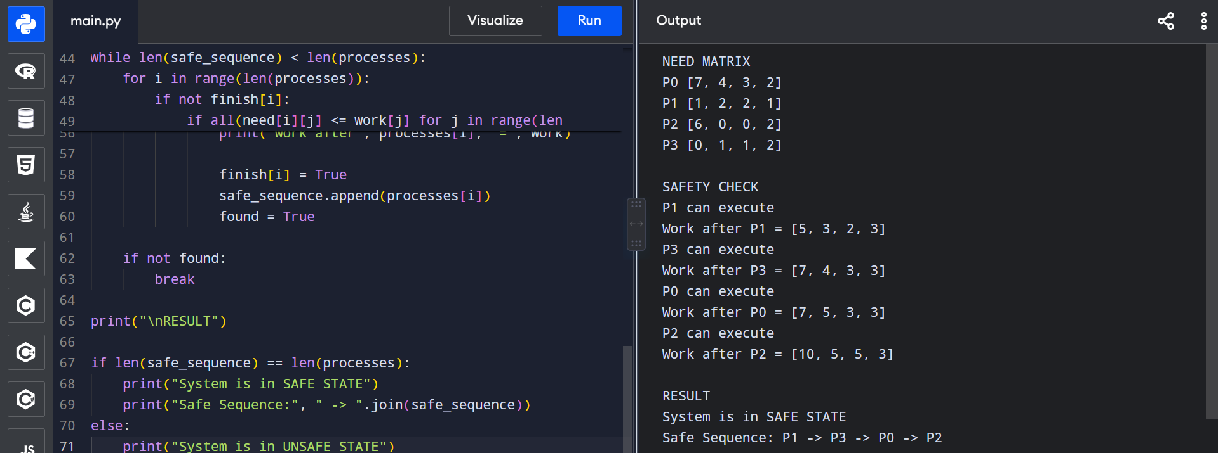

2.3 Unsafe Resource Request
CODE REQUIRED — Run this Python code and take a screenshot of the code + output.
# Unsafe Resource Request using Banker's Algorithm
processes = ["P0", "P1", "P2", "P3"]
allocation = [
[0, 1, 0, 0],
[2, 0, 0, 1],
[3, 0, 2, 0],
[2, 1, 1, 0]
]
maximum = [
[7, 5, 3, 2],
[3, 2, 2, 2],
[9, 0, 2, 2],
[2, 2, 2, 2]
]
available = [3, 3, 2, 2]
# Calculate Need
need = []
for i in range(4):
need.append([
maximum[i][j] - allocation[i][j]
for j in range(4)
])
# P0 requests additional resources
request = [4, 0, 2, 1]
print("Available Resources:", available)
print("P0 Resource Request:", request)
print("P0 Remaining Need:", need[0])
# Check Request <= Need
if all(request[j] <= need[0][j] for j in range(4)):
# Check Request <= Available
if all(request[j] <= available[j] for j in range(4)):
print("\nRequest can be temporarily allocated.")
# Temporarily allocate resources
available_test = [
available[j] - request[j]
for j in range(4)
]
allocation_test = [row[:] for row in allocation]
allocation_test[0] = [
allocation[0][j] + request[j]
for j in range(4)
]
need_test = [row[:] for row in need]
need_test[0] = [
need[0][j] - request[j]
for j in range(4)
]
# Safety test
work = available_test[:]
finish = [False] * 4
safe_sequence = []
while len(safe_sequence) < 4:
found = False
for i in range(4):
if not finish[i] and all(
need_test[i][j] <= work[j]
for j in range(4)
):
for j in range(4):
work[j] += allocation_test[i][j]
finish[i] = True
safe_sequence.append(processes[i])
found = True
if not found:
break
if len(safe_sequence) == 4:
print("Request is SAFE.")
print("Safe Sequence:", " -> ".join(safe_sequence))
else:
print("Request makes the system UNSAFE.")
print("Request must be DENIED.")
else:
print("Request exceeds available resources.")
print("Request must be DENIED.")
else:
print("Request exceeds the process maximum need.")
print("Request must be DENIED.")

OUTPUT: 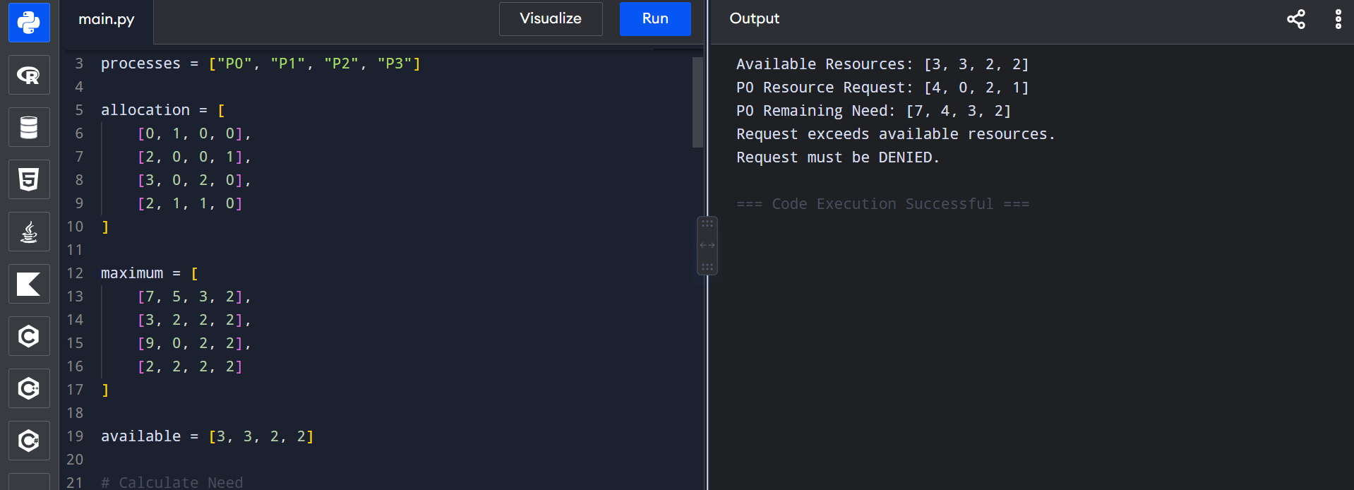
2.4 Deadlock Handling Strategies
2.4.1: Deadlock Prevention
Deadlock prevention ensures that at least one of the necessary deadlock conditions is eliminated. For UniCore, this can be achieved by restricting resource allocation rules and preventing circular wait conditions. However, strict prevention may reduce resource utilization and system flexibility.
2.4.2: Deadlock Avoidance
Deadlock avoidance checks whether a resource request keeps the system in a safe state before granting it. Banker’s Algorithm is an example of this approach. For UniCore, avoidance is suitable because resource requirements can be estimated for important services such as examinations, backups and research jobs.
2.4.3: Deadlock Detection
In deadlock detection, resources are allocated without continuously preventing deadlocks. The system periodically checks whether a deadlock has occurred. If a deadlock is detected, appropriate recovery actions are taken.
2.4.4: Deadlock Recovery
Recovery is performed after detecting a deadlock. The OS may terminate selected processes or temporarily take resources from processes and reallocate them. Although recovery can restore system operation, it may result in lost work or reduced service availability.
COMPARISION:
Strategy | Advantage | Disadvantage | Suitability for UniCore
Prevention | Avoids deadlock conditions | Can reduce resource utilization | Moderate
Avoidance | Prevents unsafe allocations | Requires maximum resource information | High
Detection | Flexible resource allocation | Deadlock may occur | Moderate
Recovery | Restores system after deadlock | May cause data/work loss | Backup approach

Selected Strategy
Deadlock avoidance using Banker’s Algorithm is selected for UniCore. It is appropriate because the university platform has limited resources and predictable resource requirements for major services. Before granting a request, the system can check whether the resulting state remains safe. Unsafe requests are temporarily denied until sufficient resources become available. This improves reliability and reduces the possibility of deadlock during peak examination workloads.
This directly addresses the assignment requirement to compare prevention, avoidance, detection and recovery and justify the selected strategy.
2.5 CPU Scheduling Analysis
For the UniCore system, CPU scheduling must provide fast response to interactive services such as online examinations while also giving sufficient CPU time to background services such as backups and research jobs. Two scheduling algorithms, Round Robin (RR) and Shortest Job First (SJF), are compared.
Workload
Process | Service | Arrival Time | Burst Time
P1 | Online Examination | 0 | 5
P2 | Digital Classroom | 1 | 3
P3 | Library Service | 2 | 8
P4 | Research Job | 3 | 6
P5 | Backup Service | 4 | 4
P6 | IoT Monitoring | 5 | 2
P7 | Research Job | 6 | 7
P8 | Backup Service | 7 | 3

Algorithm 1 – Round Robin
Round Robin is a preemptive scheduling algorithm in which each process receives a fixed time quantum. For UniCore, a time quantum of 2 units is used. This provides better responsiveness for interactive examination and classroom services.
Algorithm 2 – Shortest Job First
Shortest Job First selects the process with the smallest burst time among the available processes. It can reduce average waiting time, but longer processes may experience starvation.
CODE REQUIRED
Run this Python program and take screenshots of the code and output.
# CPU Scheduling: Round Robin and SJF
from collections import deque
processes = [
("P1", 0, 5),
("P2", 1, 3),
("P3", 2, 8),
("P4", 3, 6),
("P5", 4, 4),
("P6", 5, 2),
("P7", 6, 7),
("P8", 7, 3)
]
def round_robin(processes, quantum):
remaining = {p[0]: p[2] for p in processes}
completion = {}
ready = deque()
time = 0
added = set()
gantt = []
while len(completion) < len(processes):
for name, arrival, burst in processes:
if arrival <= time and name not in added:
ready.append(name)
added.add(name)
if not ready:
time += 1
continue
current = ready.popleft()
run_time = min(quantum, remaining[current])
gantt.append((current, time, time + run_time))
time += run_time
remaining[current] -= run_time
for name, arrival, burst in processes:
if arrival <= time and name not in added:
ready.append(name)
added.add(name)

if remaining[current] > 0:
ready.append(current)
else:
completion[current] = time
return completion, gantt
def sjf(processes):
time = 0
completed = set()
completion = {}
gantt = []
while len(completed) < len(processes):
available = [
p for p in processes
if p[1] <= time and p[0] not in completed
]
if not available:
time += 1
continue
current = min(available, key=lambda x: x[2])
name, arrival, burst = current
start = time
time += burst
completion[name] = time
completed.add(name)
gantt.append((name, start, time))
return completion, gantt

def calculate_results(processes, completion):
total_waiting = 0
total_turnaround = 0
total_response = 0
print("\nProcess Results")
print("Process AT BT CT TAT WT")
for name, arrival, burst in processes:
ct = completion[name]
tat = ct - arrival
wt = tat - burst
total_turnaround += tat
total_waiting += wt
print(f"{name:>3} {arrival:>2} {burst:>2} {ct:>2} {tat:>3} {wt:>2}")
n = len(processes)
print("\nAverage Waiting Time:", round(total_waiting / n, 2))
print("Average Turnaround Time:", round(total_turnaround / n, 2))
# Round Robin
rr_completion, rr_gantt = round_robin(processes, 2)
print("========== ROUND ROBIN ==========")
print("Time Quantum = 2")
print("Gantt Chart:")
for p, start, end in rr_gantt:
print(f"| {p} {start}-{end} ", end="")
print("|")
calculate_results(processes, rr_completion)
# SJF
sjf_completion, sjf_gantt = sjf(processes)

print("\n========== SJF ==========")
print("Gantt Chart:")
for p, start, end in sjf_gantt:
print(f"| {p} {start}-{end} ", end="")
print("|")
calculate_results(processes, sjf_completion)
OUTPUT:
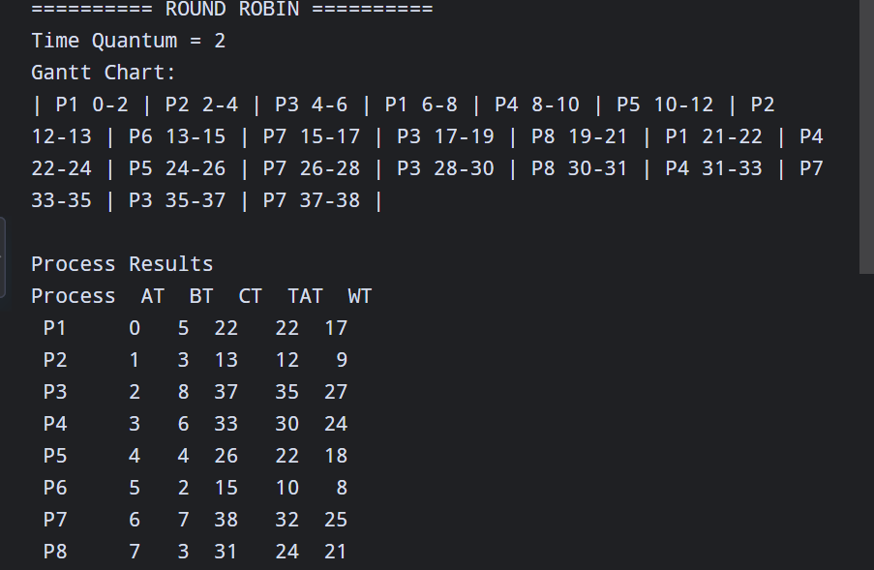
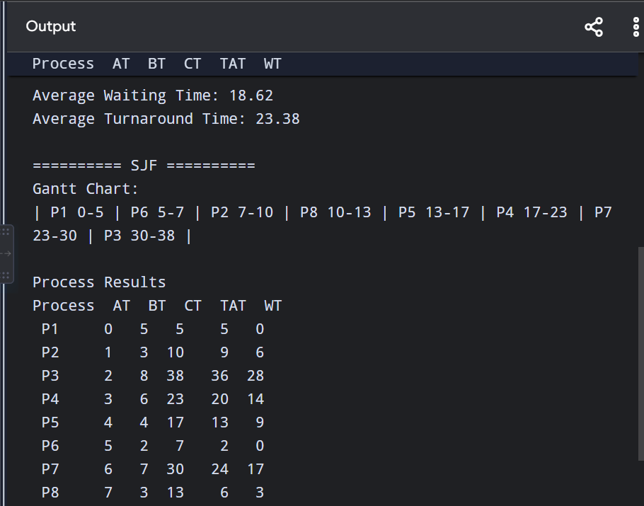
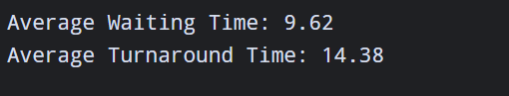
2.6 Part II – Memory Management (CO3)
Q9. Memory and Address-Space Calculation
Physical Memory:
- Physical RAM = 16 GB
- Page size = 4 KB
- Number of frames:
16 GB / 4 KB = 4,194,304 frames
Logical Address Space:
- Logical address space = 64 MB
- Page size = 4 KB
- Number of pages:
64 MB / 4 KB = 16,384 pages
Page Table Organization
The logical address is divided into:
Logical Address → Page Number + Page Offset
- Page number identifies the required page.
- Page offset identifies the exact location within that page.
- The page table maps each logical page to a physical frame.
Conclusion
The UniCore system has 4,194,304 physical frames and each 64 MB logical address space contains 16,384 pages. Paging allows the system to efficiently manage memory for many concurrent users.
PART II — MEMORY MANAGEMENT (CO3)
This covers Q9–Q13 from your assignment.

Q9. Memory and Address-Space Calculation
Physical Memory
- Physical RAM = 16 GB
- Page size = 4 KB
Number of frames:
16 GB ÷ 4 KB = 4,194,304 frames
Logical Address Space
- Logical address space = 64 MB
- Page size = 4 KB
Number of pages:
64 MB ÷ 4 KB = 16,384 pages
Page Table Organization
The logical address is divided into:
Logical Address → Page Number + Page Offset
The page number identifies the required logical page, while the offset identifies the exact location within that page. The page table maps logical pages to physical frames.

Q10. Page Replacement Algorithms
CODE REQUIRED
Use a reference string containing at least 15 page references and compare:
- FIFO
- LRU
- Optimal
- 3 Frames
- 4 Frames
Python Code
reference = [7, 0, 1, 2, 0, 3, 0, 4, 2, 3, 0, 3, 2, 1, 2, 0, 1]
def fifo(pages, frames):
memory = []
faults = 0
states = []
for page in pages:
if page not in memory:
faults += 1
if len(memory) < frames:
memory.append(page)
else:
memory.pop(0)
memory.append(page)
states.append(memory.copy())
return faults, states
def lru(pages, frames):
memory = []
faults = 0
states = []
for page in pages:
if page in memory:
memory.remove(page)
memory.append(page)
else:
faults += 1
if len(memory) >= frames:
memory.pop(0)
memory.append(page)
states.append(memory.copy())
return faults, states
def optimal(pages, frames):
memory = []
faults = 0
states = []
for i, page in enumerate(pages):
if page not in memory:
faults += 1

if len(memory) < frames:
memory.append(page)
else:
future = pages[i + 1:]
distances = []
for p in memory:
if p in future:
distances.append(future.index(p))
else:
distances.append(float('inf'))
replace_index = distances.index(max(distances))
memory[replace_index] = page
states.append(memory.copy())
return faults, states
for frames in [3, 4]:
print("\nFrames:", frames)
f_faults, _ = fifo(reference, frames)
l_faults, _ = lru(reference, frames)
o_faults, _ = optimal(reference, frames)
print("FIFO Faults :", f_faults)
print("LRU Faults :", l_faults)
print("Optimal Faults:", o_faults)
OUTPUT:
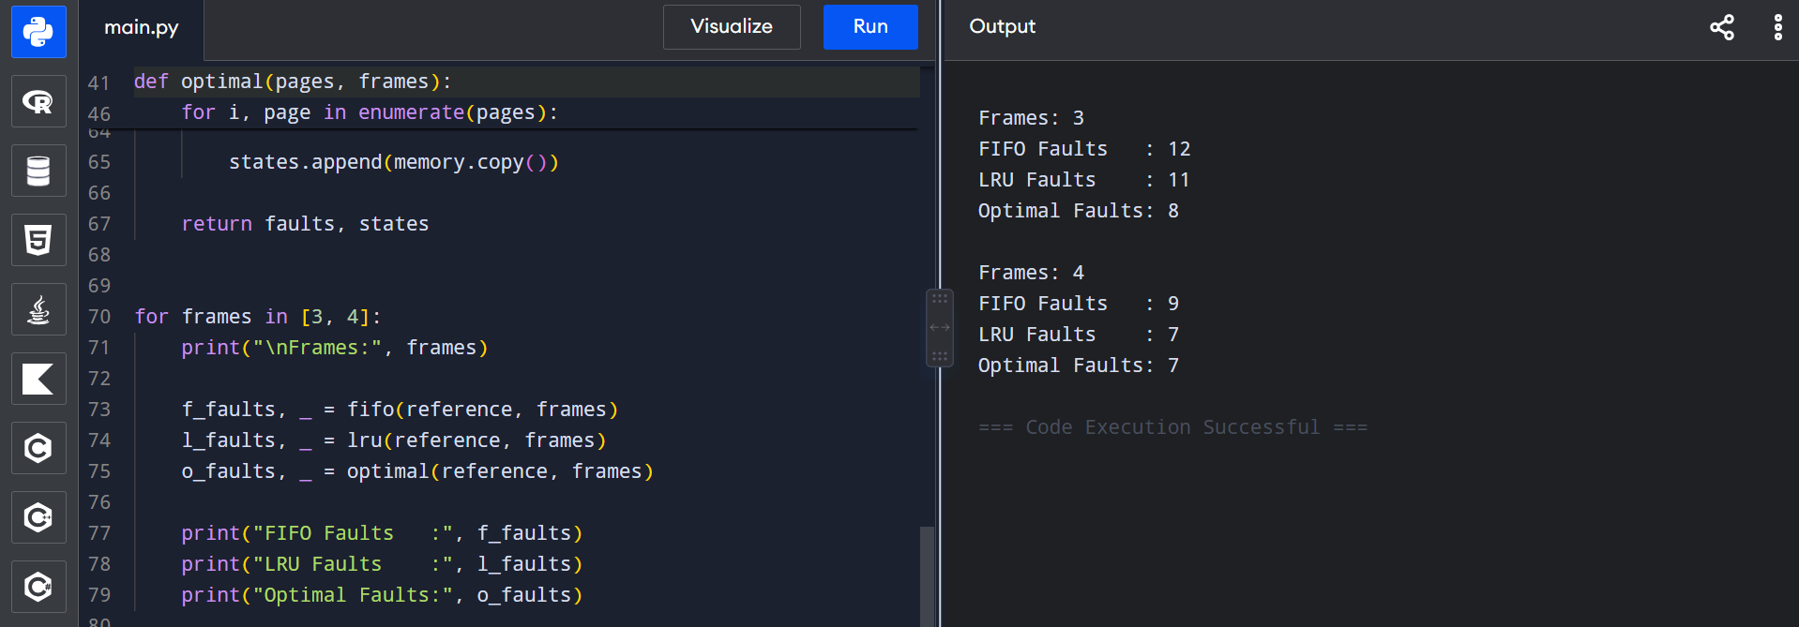
Expected Comparison Table
Algorithm | 3 Frames | 4 Frames
FIFO | Run code | Run code
LRU | Run code | Run code
Optimal | Run code | Run code
Result
Optimal generally produces the minimum number of page faults because it replaces the page that will not be needed for the longest future period. LRU uses recent usage information, while FIFO replaces the oldest page.

Q11. Belady's Anomaly
CODE REQUIRED
Belady's anomaly can occur in FIFO, where increasing the number of frames can sometimes increase the number of page faults.
Use this code:
reference = [1, 2, 3, 4, 1, 2, 5, 1, 2, 3, 4, 5]
def fifo_faults(pages, frames):
memory = []
faults = 0
for page in pages:
if page not in memory:
faults += 1
if len(memory) < frames:
memory.append(page)
else:
memory.pop(0)
memory.append(page)
return faults
for frames in range(3, 6):
faults = fifo_faults(reference, frames)
print("Frames:", frames, "Page Faults:", faults)

OUTPUT:
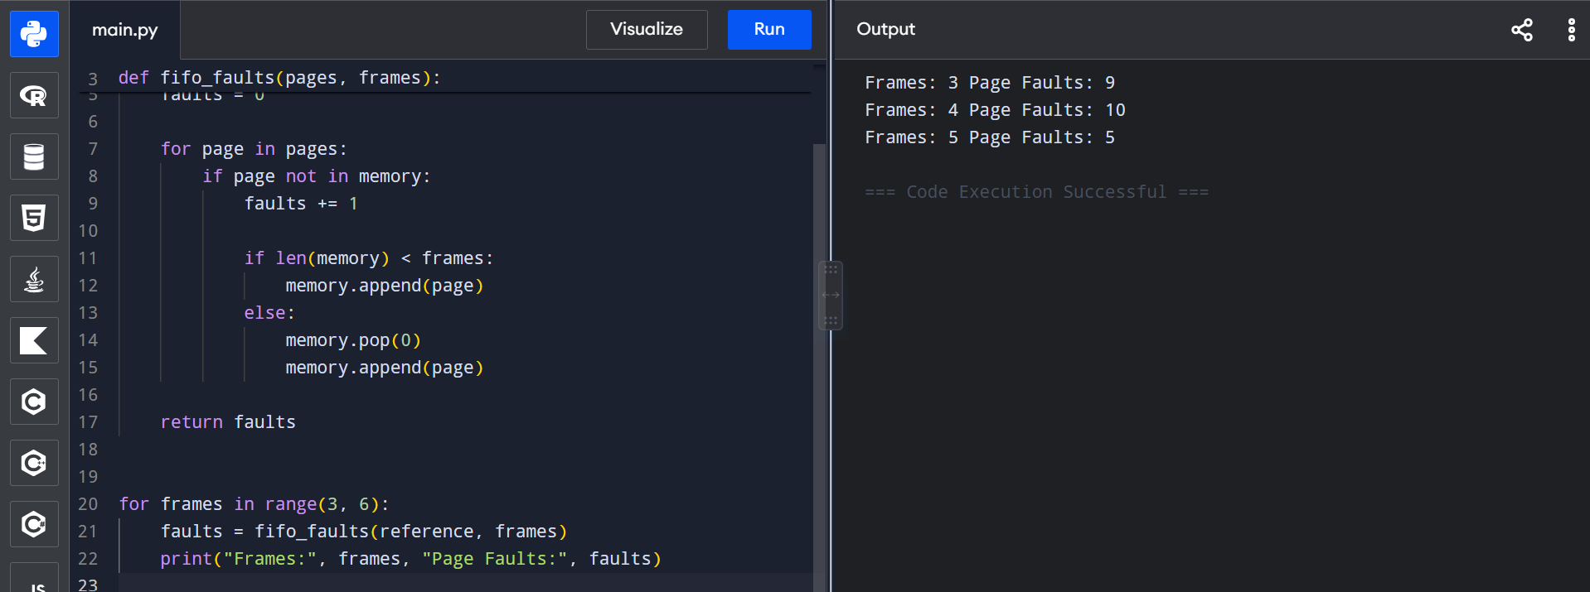
Analysis
The number of page faults is calculated for different numbers of frames. If faults increase after adding a frame, it demonstrates Belady's anomaly.

Q12. Demand Paging, Working Set and Thrashing
CODE REQUIRED?
Demand Paging
Demand paging loads a page into physical memory only when that page is actually required.
For the UniCore system, this avoids loading unnecessary pages for all users simultaneously.
Working Set
The working set is the collection of pages actively used by a process during a particular time interval.
For example:
Process → {Page 2, Page 4, Page 5, Page 8}
These pages should preferably remain in memory.
Thrashing
Thrashing occurs when the system spends more time handling page faults and swapping pages than executing processes.
With 800 concurrent users during examinations, excessive memory demand can cause thrashing.
Frame Allocation Policy
The recommended policy is:
- Allocate minimum frames to every active process.
- Give additional frames to processes with larger working sets.
- Monitor page-fault rates.
- Reduce memory pressure by controlling inactive/background processes.
- Prioritize examination and interactive services.
Conclusion
A working-set-based allocation strategy can reduce unnecessary page faults and help prevent thrashing during peak examination periods.

Q13. Linking, Dynamic Linking and Memory Impact
CODE REQUIRED
Static Linking
In static linking, required library code is included directly inside the executable.
Advantages:
- Faster loading.
- No dependency on external library files.
Disadvantage:
- Executable files become larger.
- Multiple processes may contain duplicate library code.
Dynamic Linking
In dynamic linking, libraries are loaded or linked when required.
Advantages:
- Reduces executable size.
- Shared libraries can be used by multiple processes.
- Saves memory when common libraries are shared.
Disadvantages:
- Requires library availability.
- Linking/loading may introduce some overhead.
Impact on UniCore
Dynamic linking is preferable for a large university platform because multiple services may use the same libraries. Sharing common libraries can reduce memory consumption and improve overall resource utilization.

CO3 FINAL COMPARISON
Topic | Technique/Decision
Physical Memory | 16 GB
Page Size | 4 KB
Physical Frames | 4,194,304
Logical Address Space | 64 MB
Logical Pages | 16,384
Page Replacement | FIFO, LRU, Optimal
Frame Comparison | 3 and 4 frames
Anomaly | Belady's Anomaly
Memory Strategy | Demand Paging
Thrashing Control | Working Set + Frame Allocation
Linking | Dynamic Linking preferred

PART III — FILE & DISK MANAGEMENT (CO4)
This covers Q14–Q18 from your assignment.
Q14. File Allocation Methods
CODE REQUIRED
Compare the three methods for UniCore:

File Type | Contiguous | Linked | Indexed
Small student records | Excellent | Good | Good
Medium documents | Excellent | Good | Good
Large videos | Good | Excellent | Excellent
Sequential access | Excellent | Good | Good
Random access | Excellent | Poor | Excellent
Fragmentation | Possible | Low | Low
Analysis
Contiguous allocation stores a file in consecutive disk blocks. It provides fast access but can suffer from external fragmentation.
Linked allocation stores file blocks anywhere on the disk and connects them using pointers. It avoids external fragmentation but random access is slower.
Indexed allocation uses an index block containing pointers to the file's data blocks. It supports direct access and is suitable for large files.
Recommendation
For the UniCore system:
- Student records: Contiguous allocation
- Medium documents: Indexed allocation
- Large videos: Indexed allocation
Indexed allocation is a good general choice when files require flexible growth and random access.

Q15. Disk Scheduling Algorithms
CODE REQUIRED
Given
- Disk cylinders = 0–199
- Initial head position = 50
- Requests = 82, 170, 43, 140, 24, 16, 190, 60, 90, 10
Run this:
requests = [82, 170, 43, 140, 24, 16, 190, 60, 90, 10]
head = 50
def fcfs(requests, head):
movement = 0
current = head
for r in requests:
movement += abs(current - r)
current = r
return movement
def sstf(requests, head):
pending = requests.copy()
movement = 0
current = head

while pending:
nearest = min(pending, key=lambda x: abs(current - x))
movement += abs(current - nearest)
current = nearest
pending.remove(nearest)
return movement
def scan(requests, head, disk_size=200):
left = sorted([r for r in requests if r < head], reverse=True)
right = sorted([r for r in requests if r >= head])
movement = 0
current = head
for r in right:
movement += abs(current - r)
current = r
movement += abs(current - (disk_size - 1))
current = disk_size - 1
for r in left:
movement += abs(current - r)
current = r
return movement
print("FCFS Movement :", fcfs(requests, head))
print("SSTF Movement :", sstf(requests, head))
print("SCAN Movement :", scan(requests, head))

OUTPUT:
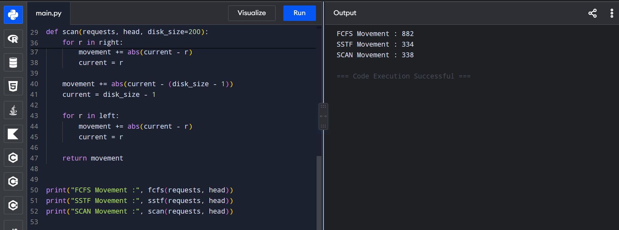

Comparison:
Algorithm | Total Head Movement
FCFS | Run code
SSTF | Run code
SCAN | Run code

Q16. Seek Performance and Fairness
CODE REQUIRED
Comparison
Algorithm | Seek Performance | Fairness | Main Issue
FCFS | Low | High | Large head movement
SSTF | High | Medium/Low | Possible starvation
SCAN | High | High | More predictable
Analysis
SSTF usually provides lower average seek time because it services the nearest request first. However, requests far from the current head may wait for a long time.
SCAN provides more predictable service because the disk head moves in a fixed direction and services requests along the way.
Decision
For UniCore, SCAN is preferred for production use because it provides a good balance between performance and fairness.

Q17. Unix Inodes and Buffer Cache
CODE REQUIRED
Unix Inode
An inode stores important information about a file, such as:
- File type
- File permissions
- File owner
- File size
- Timestamps
- Pointers to data blocks
The filename is stored separately in the directory and maps to the inode.
Buffer Cache
The buffer cache temporarily stores frequently accessed disk blocks in memory.
Instead of repeatedly accessing the disk, the operating system can retrieve frequently used data from memory.
Benefits for UniCore
- Faster file access
- Reduced disk I/O
- Improved application response time
- Better performance for frequently accessed LMS and library files

Q18. File Allocation + Disk Scheduling Impact
CODE REQUIRED
File allocation and disk scheduling work together to affect overall response time.
Relationship
File Allocation → Location of Blocks → Disk Requests → Disk Scheduling → Response Time
For example, contiguous allocation keeps blocks close together, which can reduce seek movement for sequential access.
Indexed allocation provides flexible access but may require additional index-block access.
Disk scheduling then determines the order in which pending requests are served.
UniCore Recommendation
For frequently accessed student records and documents, efficient allocation combined with SCAN disk scheduling can provide predictable performance.
For large files such as recorded lectures and videos, indexed allocation provides flexibility while disk scheduling reduces unnecessary head movement.
Overall Conclusion
An effective combination of file allocation and disk scheduling can reduce disk access time, improve fairness, and provide better response time during peak university workloads.
3. Integrated OS Architecture and Design
3.1 Overall Architecture
The proposed UniCore OS Resource Orchestration System integrates process management, synchronization, deadlock handling, memory management, file allocation, and disk scheduling into a single operating-system resource management framework.
Architecture Flow:

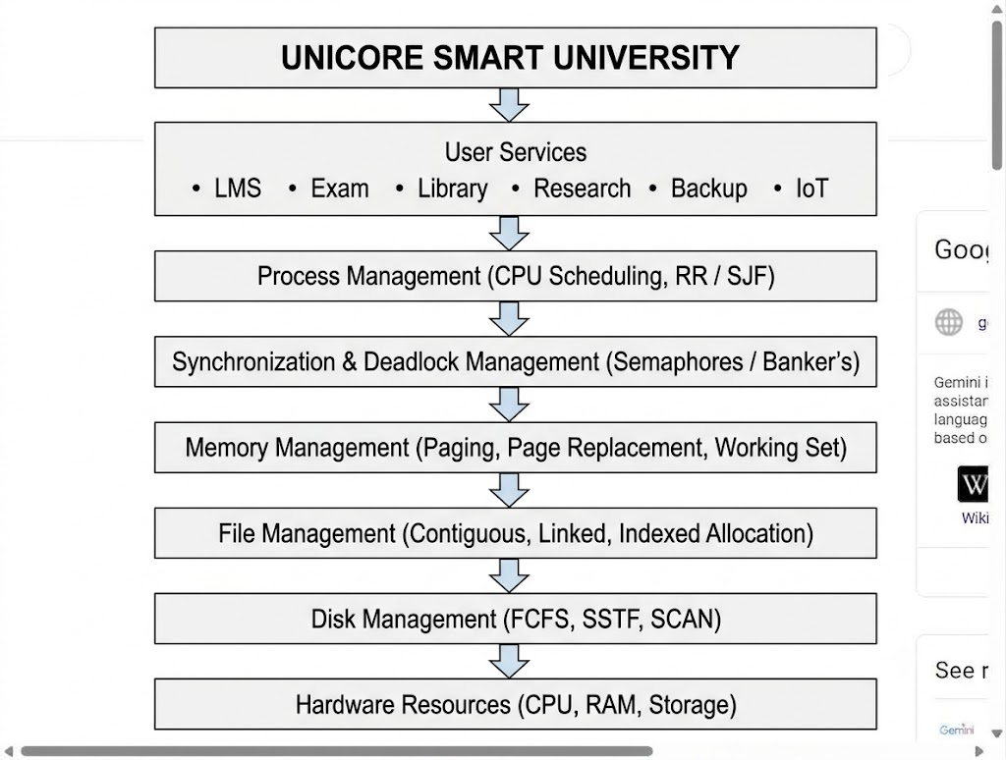

3.2 Data and Control Flow
The system follows this sequence:
- A user accesses a UniCore service.
- The operating system creates and manages the required process.
- CPU scheduling determines which process receives CPU time.
- Synchronization mechanisms control shared resources.
- Banker’s Algorithm checks whether resource allocation keeps the system safe.
- Memory management allocates frames and handles page faults.
- File management determines how files are stored.
- Disk scheduling determines the order of disk requests.
- The hardware executes the requested operations.
- Performance information is collected for monitoring and analysis.

Simplified Flow:
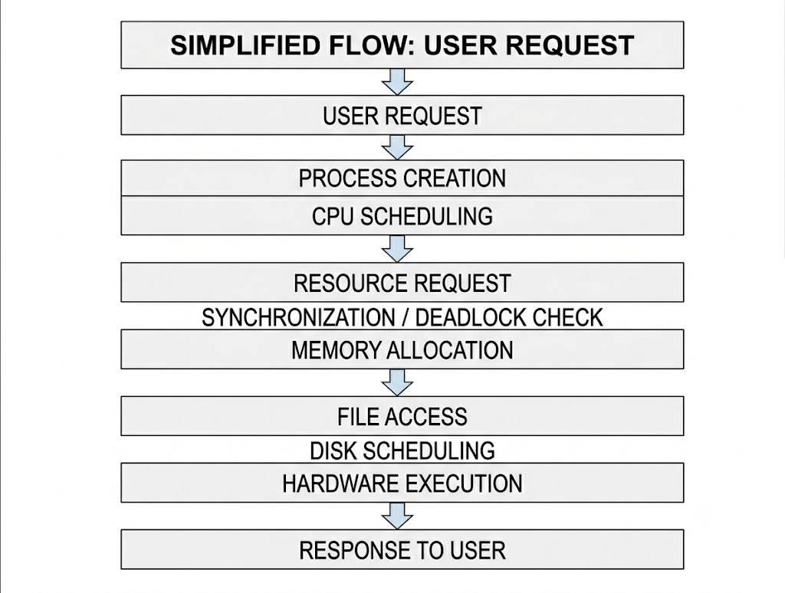

3.3 Module Integration
Module | Main Function | Technique Used
Process Management | Manage university processes | Round Robin / SJF
Synchronization | Control shared resources | Semaphores
Deadlock Management | Avoid unsafe allocation | Banker’s Algorithm
Memory Management | Manage RAM and pages | Paging
Page Replacement | Handle page faults | FIFO / LRU / Optimal
File Management | Store files efficiently | Indexed Allocation
Disk Management | Schedule disk requests | SCAN
The modules are interconnected. CPU scheduling controls process execution, while synchronization and deadlock management control resource access. Memory management provides required pages, and file and disk management handle persistent storage.

3.4 Design Decision Matrix
Decision Area | Options Considered | Selected | Reason
CPU Scheduling | FCFS, SJF, RR | RR | Good response for interactive users
Synchronization | Mutex, Semaphore, Monitor | Semaphore | Suitable for shared resources
Deadlock | Prevention, Avoidance, Detection | Banker’s Algorithm | Prevents unsafe allocation
Page Replacement | FIFO, LRU, Optimal | LRU | Practical balance between performance and implementation
File Allocation | Contiguous, Linked, Indexed | Indexed | Flexible and supports direct access
Disk Scheduling | FCFS, SSTF, SCAN | SCAN | Good balance of performance and fairness
Memory Strategy | Simple allocation, Paging | Paging | Efficient memory utilization

Final Engineering Choice
The integrated design uses Round Robin for interactive process scheduling, semaphores for synchronization, Banker’s Algorithm for deadlock avoidance, paging with LRU page replacement, indexed file allocation, and SCAN disk scheduling.This combination provides a balance between performance, fairness, resource utilization, reliability, and scalability for the UniCore smart university environment.
4. Modern Tools and Technologies
The UniCore resource orchestration system can be developed and evaluated using open-source tools. The selected tools support implementation, simulation, testing, version control, and documentation.
Tool / Technology | Purpose
Python | Implement OS algorithms and simulations
C / C++ | Alternative implementation of OS concepts
Linux / WSL | Operating-system environment and testing
OS Simulator | Simulate scheduling and resource-management operations
GitHub | Store source code and maintain versions
VS Code | Development and debugging
Matplotlib | Generate performance graphs
Documentation Tools | Prepare README, test cases and reports

Testing Approach
The implementation should be tested using:
- Normal workload conditions.
- High-load examination conditions.
- Safe and unsafe resource requests.
- Different numbers of memory frames.
- Multiple disk-request sequences.
- Different process arrival and burst times.
Version Control
GitHub is used to maintain:
- Source code
- Test cases
- Results
- Documentation
- README
- Project versions
This makes the implementation reproducible and easier to maintain.
5. Results and Validation
This section should contain the actual outputs from the codes you already ran. The assignment specifically requires measurable results such as scheduling metrics, safety traces, page faults and disk head movement.
5.1 CPU Scheduling Results
Include the output from Q8.
OUTPUT:
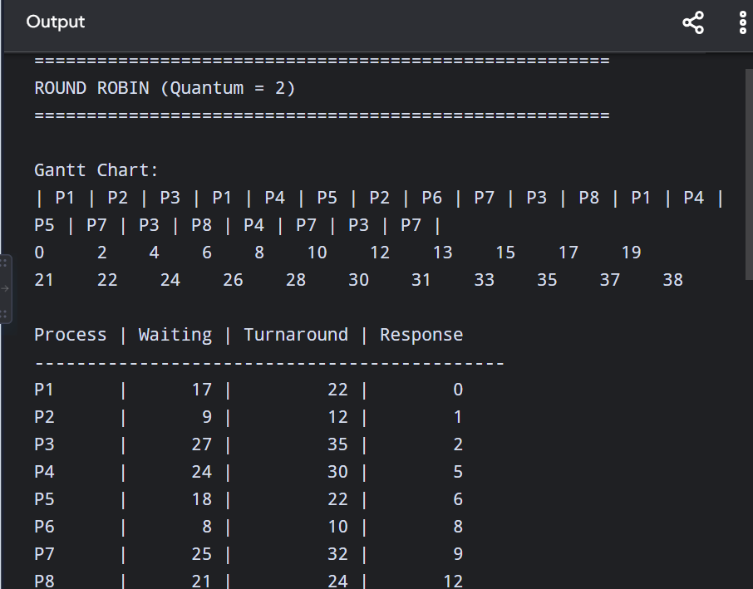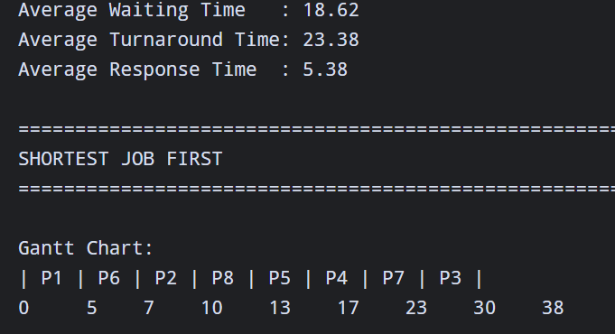
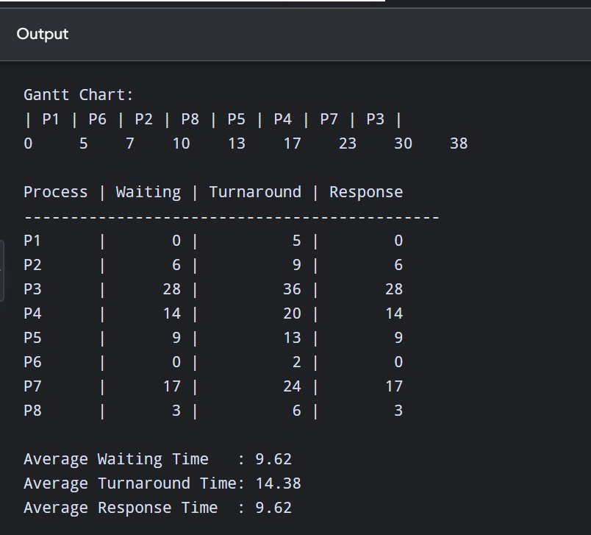
Algorithm | Average Waiting Time | Average Turnaround Time | Response Time
Round Robin | From output | From output | From output
SJF | From output | From output | From output

5.2 Banker’s Algorithm Result
The system was tested using the Allocation, Maximum, Available and Need matrices.
Result: The system can determine whether the current state is safe and produce a safe sequence. An unsafe additional request is denied to prevent the system from entering an unsafe state.
5.3 Page Replacement Results
Use your Q10 and Q11 outputs.
OUTPUT:
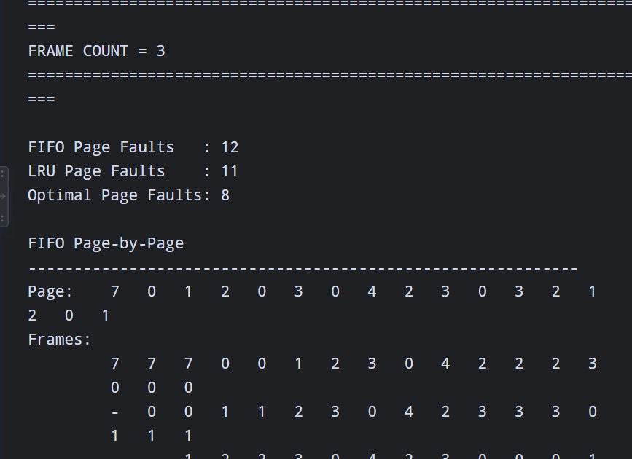
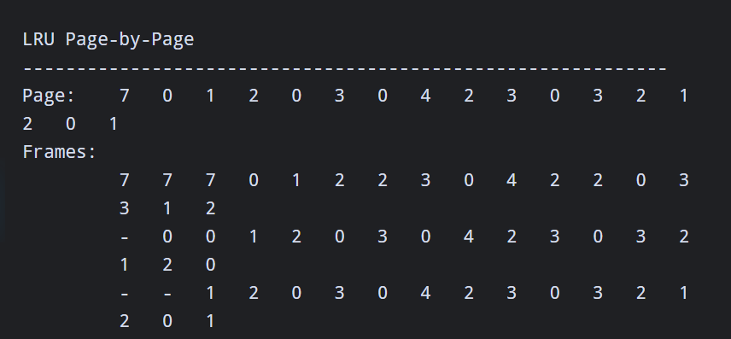
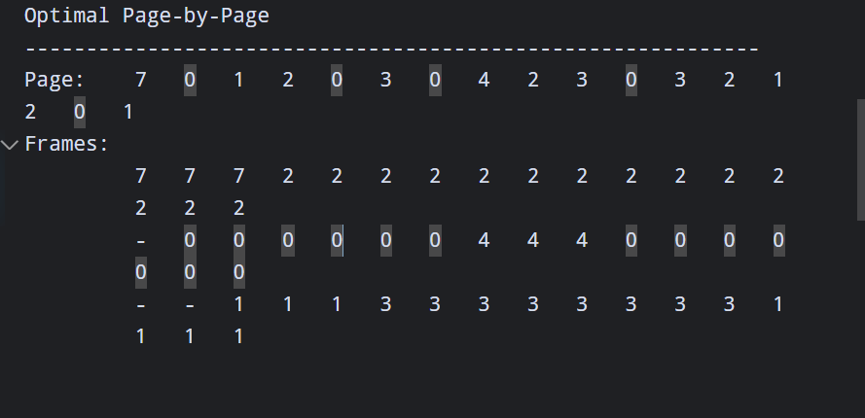
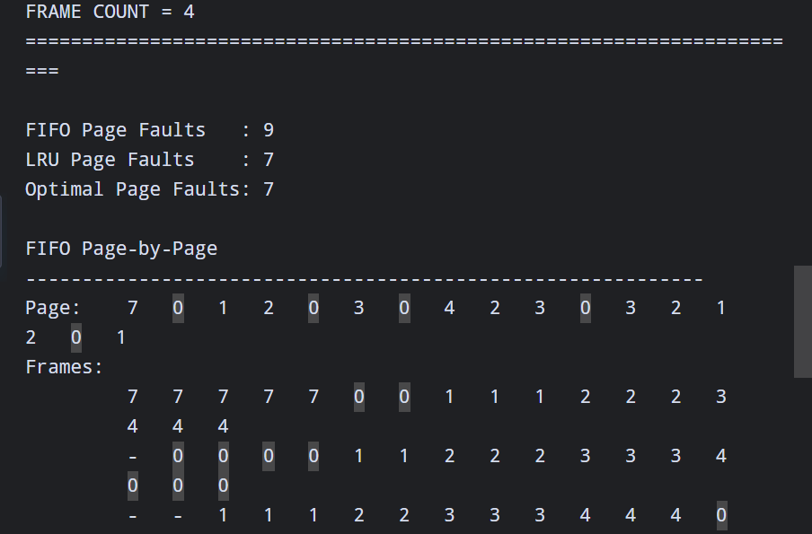
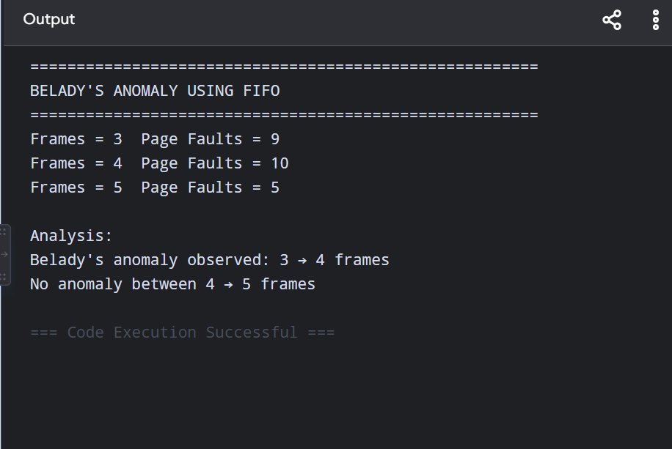
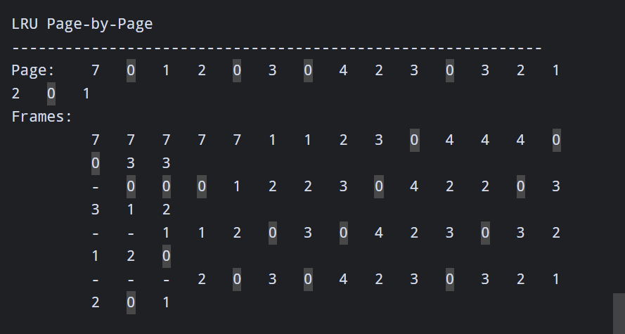
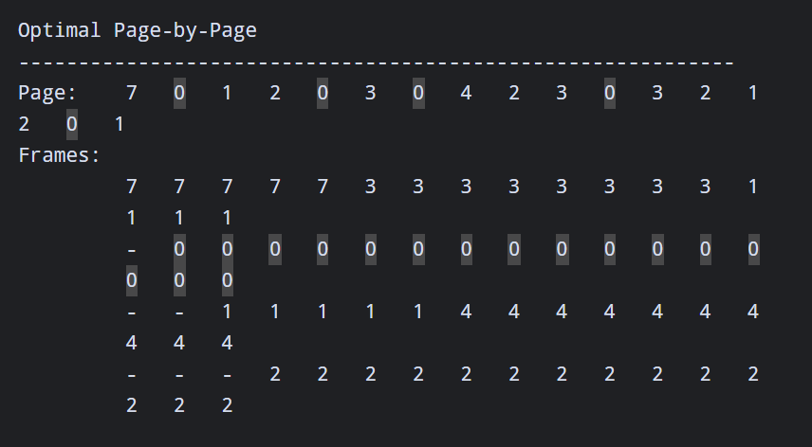

Algorithm | 3 Frames | 4 Frames
FIFO | Your output | Your output
LRU | Your output | Your output
Optimal | Your output | Your output

5.4 Disk Scheduling Results
Use your Q15 output.
Algorithm | Total Head Movement
FCFS | Your output
SSTF | Your output
SCAN | Your output

OUTPUT:
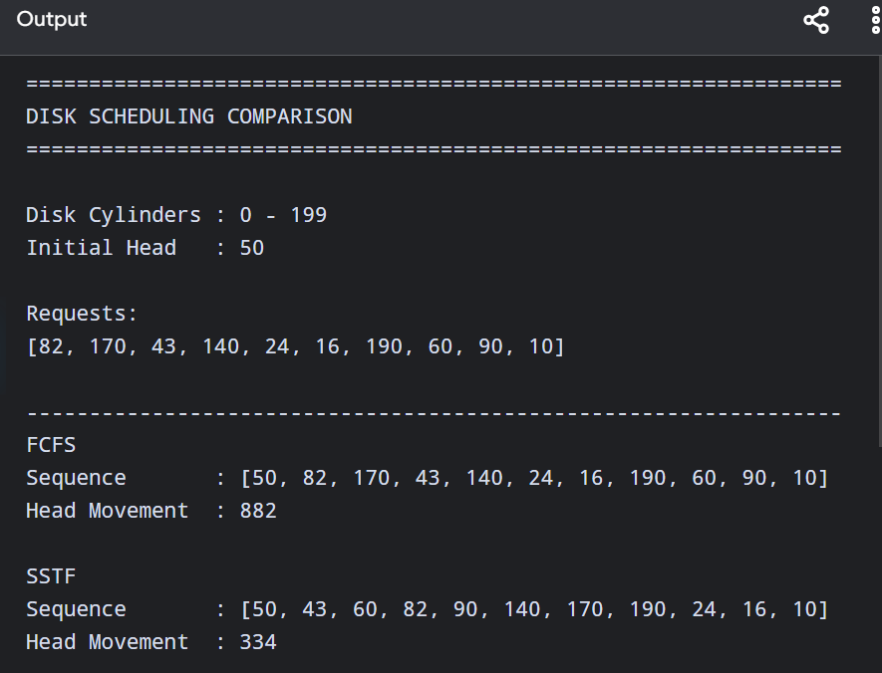
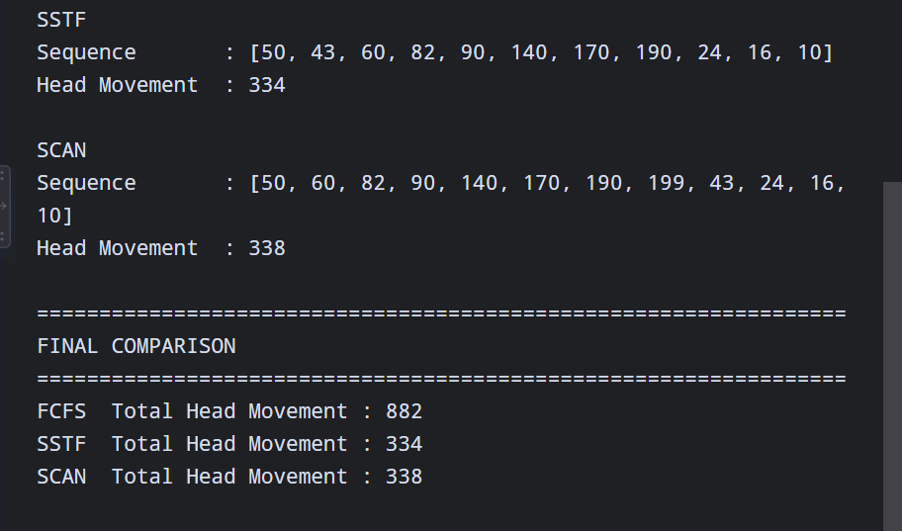
5.5 Validation
The system is validated by comparing the algorithms under normal and adverse conditions. The results demonstrate the effect of scheduling, memory allocation, deadlock avoidance and disk scheduling on overall system performance.
6. Engineering Decisions
The main engineering decisions were selected based on performance, fairness, safety, memory utilization, and scalability.
Area | Selected Decision | Reason
CPU Scheduling | Round Robin | Good response for interactive users
Synchronization | Semaphores | Prevents race conditions
Deadlock | Banker’s Algorithm | Avoids unsafe states
Memory | Paging | Efficient memory utilization
Page Replacement | LRU | Practical replacement strategy
File Allocation | Indexed | Flexible file growth and direct access
Disk Scheduling | SCAN | Balances seek performance and fairness

Trade-offs
Round Robin provides better responsiveness but can have scheduling overhead. SJF can reduce waiting time but may delay longer jobs. SSTF can reduce disk movement but may cause starvation. SCAN provides more predictable and fair disk access.
Therefore, the final design prioritizes balanced performance rather than optimizing only one metric.

7. Reliability, Safety, Sustainability and Ethics
7.1 Reliability and Safety
- Banker’s Algorithm prevents unsafe resource allocation.
- Synchronization mechanisms prevent race conditions.
- Regular backups improve data recovery.
- Resource monitoring can identify overloaded components.
- Testing with adverse workloads improves system reliability.
7.2 Sustainability
Efficient CPU, memory and disk management reduces unnecessary resource usage. Dynamic linking and effective memory allocation can reduce memory consumption and improve hardware utilization.
7.3 Accessibility and Society
The system should provide reliable access to LMS, examinations and digital resources for students with different technical abilities. Services should remain responsive during high-demand examination periods.
7.4 Ethics and Privacy
The system may process student records, examination information and research data. Therefore:
- Access should be role-based.
- Sensitive information should be protected.
- User activity should be handled responsibly.
- Only necessary data should be collected.
- Administrative access should be controlled.
These considerations are important for a university-wide resource-management platform.

8. Conclusion
The UniCore Smart University Resource Orchestration System demonstrates how operating-system concepts can be integrated to manage a large and dynamic university workload. Process scheduling, synchronization, deadlock avoidance, memory management, file allocation and disk scheduling were analyzed as interconnected components. Round Robin provides responsive process execution, while semaphores prevent synchronization problems and Banker’s Algorithm maintains safe resource allocation. Paging and page-replacement techniques improve memory utilization, while indexed allocation and SCAN scheduling provide flexible and predictable storage management. The integrated approach provides a balance between performance, fairness, reliability and scalability, making it suitable for normal university workloads as well as high-demand examination periods.
9.Individual Reflection:
Working on the UniCore Smart University Resource Orchestration System helped me understand how different operating-system concepts work together in a practical environment. I learned that process scheduling, synchronization, deadlock management, memory management, file allocation and disk scheduling cannot be considered as completely separate concepts because a change in one resource-management decision can affect the overall system performance.The most important learning experience was comparing different algorithms using measurable results. CPU scheduling helped me understand the importance of waiting time, turnaround time and response time. Banker’s Algorithm showed how resource allocation can be checked before granting a request. Page replacement algorithms demonstrated the effect of memory management on page faults, while disk scheduling showed how the order of requests can influence disk head movement.
The performance-impact decision I considered most important was selecting suitable algorithms based on the type of workload instead of selecting an algorithm only because it produces the best result for one metric. For example, an algorithm with low average waiting time may not always provide the best fairness. Similarly, an algorithm with low disk movement may not always be the best choice for a production environment if some requests experience long delays.If the system had to support 2,000 concurrent users, I would improve the design by introducing better workload distribution, dynamic resource allocation, stronger monitoring, efficient caching and scalable storage. I would also increase testing with high-load and adverse scenarios to identify bottlenecks before deployment.Overall, this assignment improved my understanding of how operating-system principles can be combined to design a reliable, efficient and scalable resource-management system.

10. References
Use references such as:
- Abraham Silberschatz, Peter B. Galvin and Greg Gagne, Operating System Concepts, Wiley.
- Andrew S. Tanenbaum and Herbert Bos, Modern Operating Systems, Pearson.
- William Stallings, Operating Systems: Internals and Design Principles, Pearson.
- Python Software Foundation, Python Documentation.
- Linux Kernel Documentation.
- GitHub Documentation.
- Operating-system scheduling, synchronization, memory-management and file-system documentation.

